Step1:Connect to umkc VPN. Login to cloudera manager using http://134.193.136.147:7180.

Step2:download putty and enter the hostname as shown below.

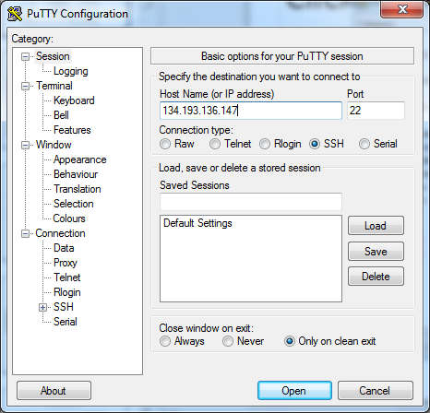

Step3:enter username and password as group9 in putty
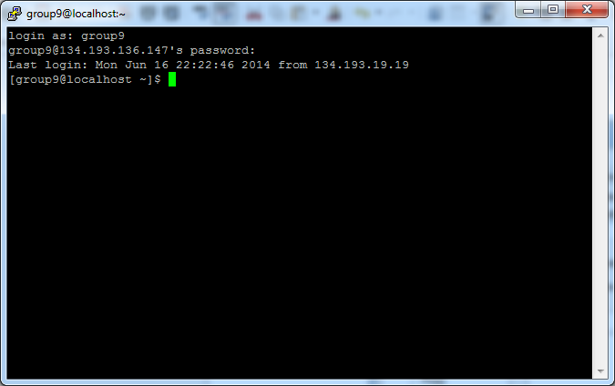
step4: download Winscp and enter host name as shown below and enter the username and password as group9

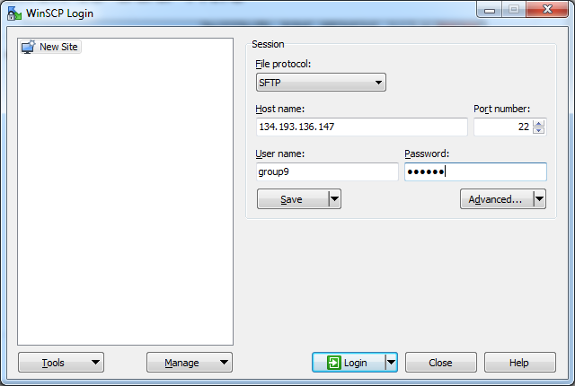

Download the word count file from the link provided and
Drag and drop the word count file from local machine to virtual machine as shown below:

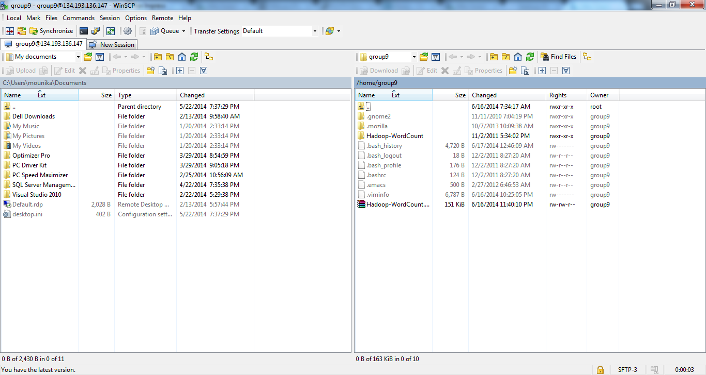

open putty and type in 'cd $Hadoop_Home',type commands 'unzip Hadoop-WordCount.zip'

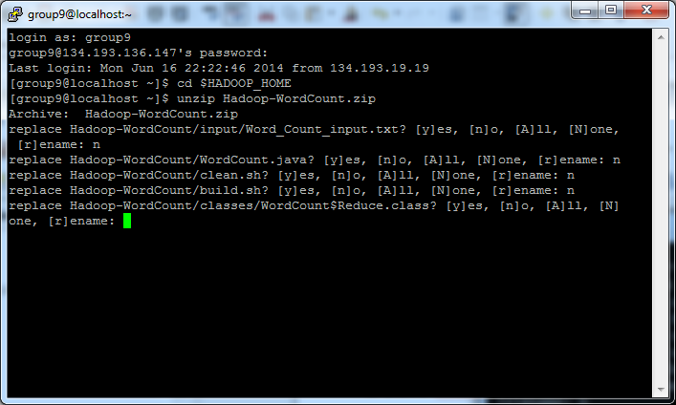

when we type a command 'hadoop fs -put input input', it is showing no such file or directory exists.Hadoop commannds are not working.

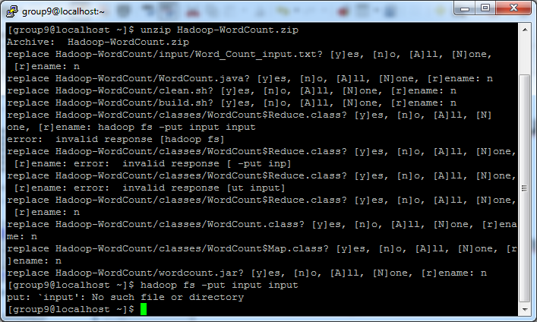

SCRUMBDO:

After creating an account:
Creating an organization as UMKC and project as BIG DATA
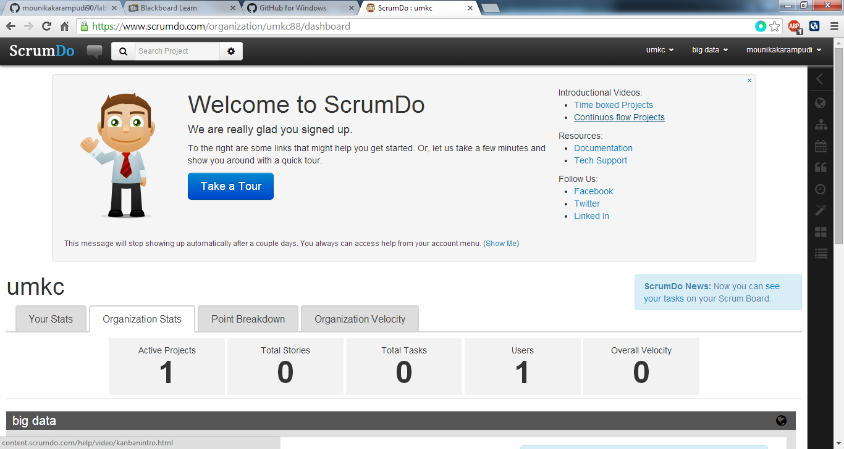

To add a story in project Big Data.select Add story option and enter the story.
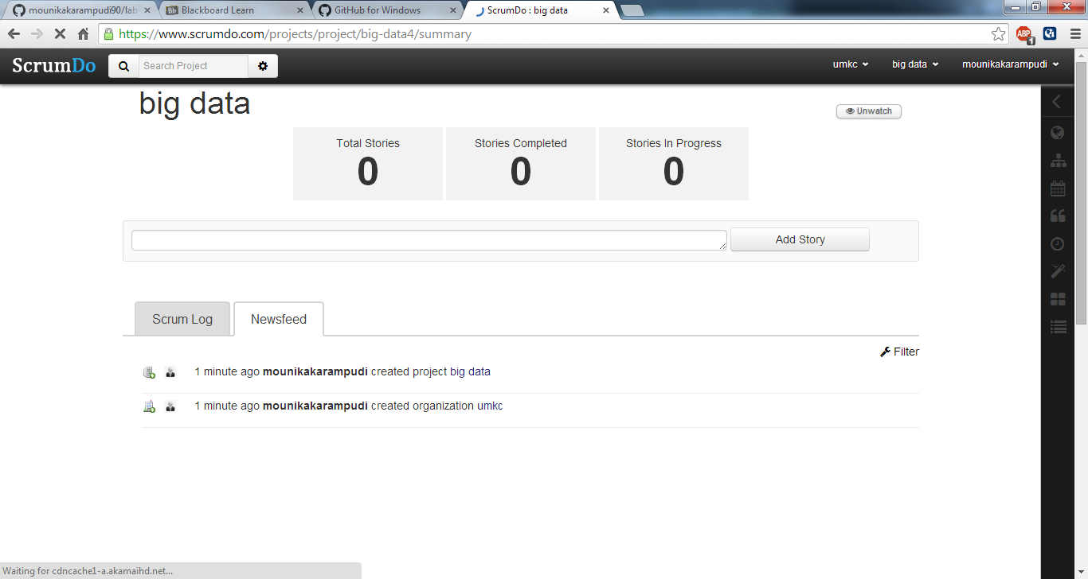

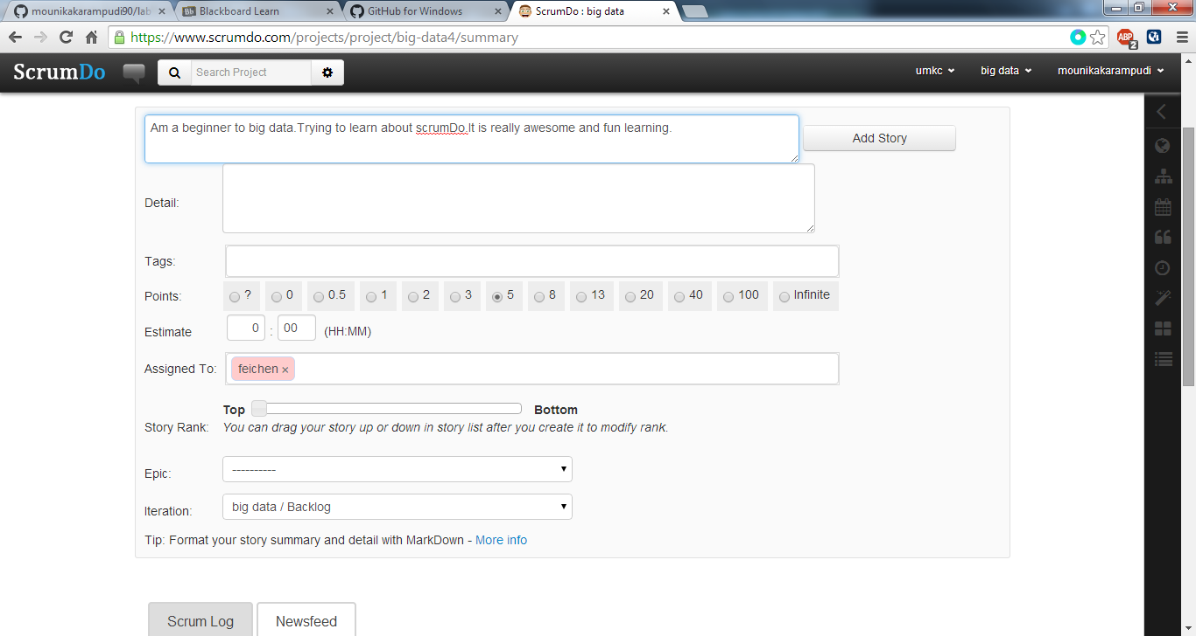

A story one is created on clicking Add story button.
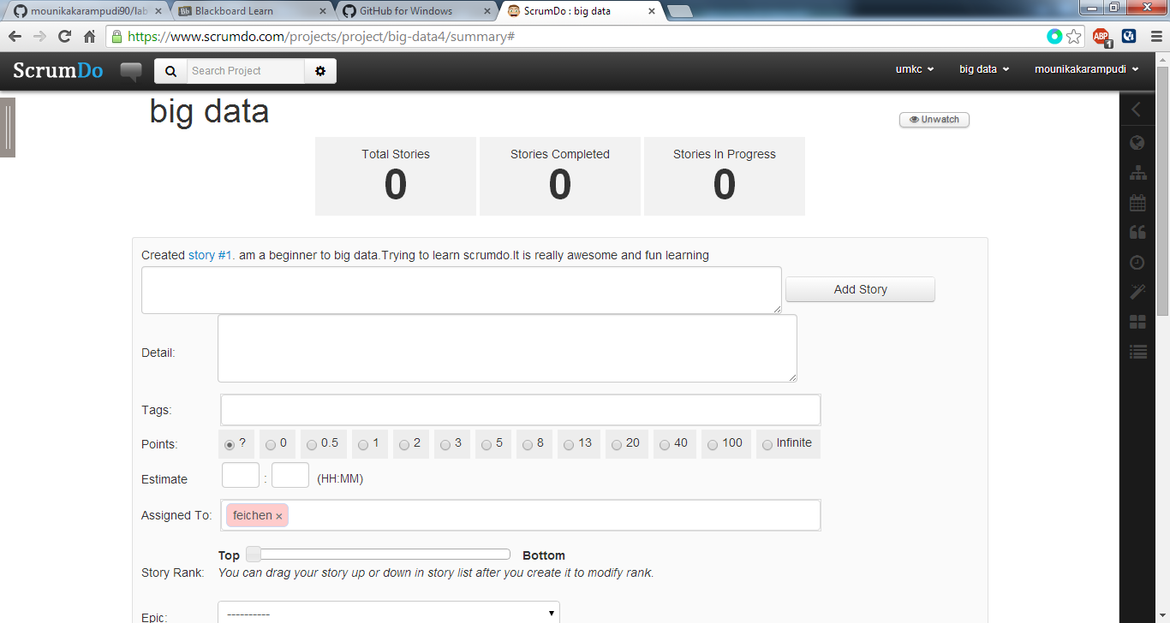

The story is displayed in Backlog folder,as shown below

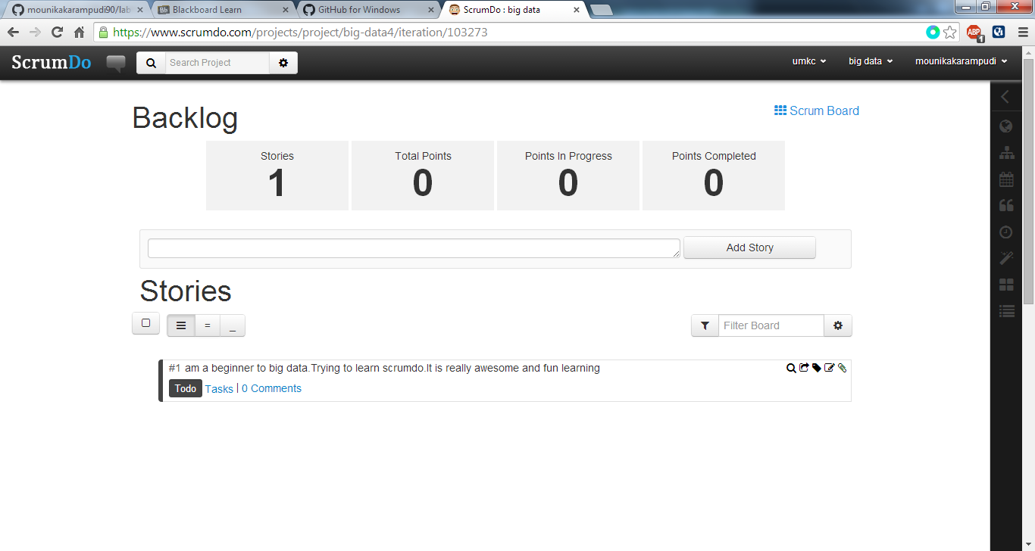

Creating a new iteration,go to big data,in the drop down select iteration and enter the new iteration as below.
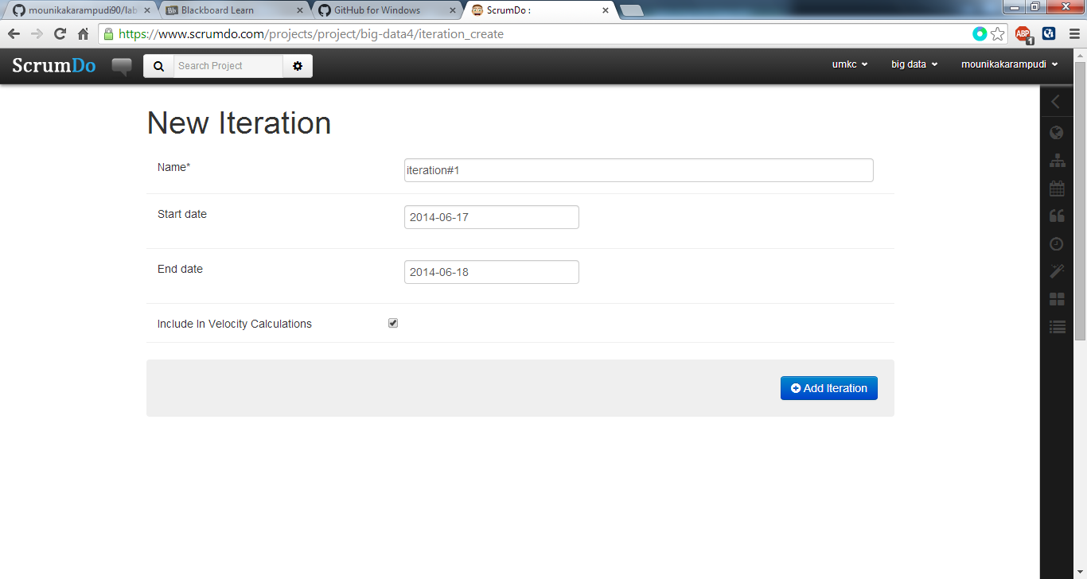

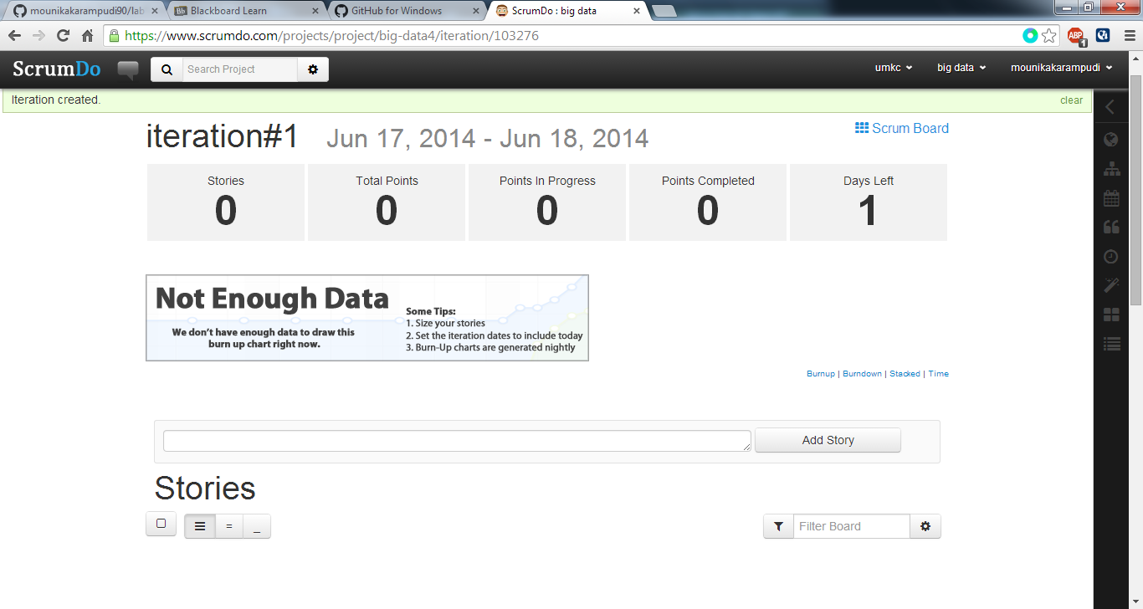

Creating a new Epic.Go to Big data select epic and enter the summary,we can create epic as shown below

